<https://viewer.diagrams.net/?tags=%7B%7D&highlight=0000ff&edit=_blank&layers=1&nav=1&title=Ejercicio%20BaseN.drawio.svg#Uhttps%3A%2F%2Fdrive.google.com%2Fuc%3Fid%3D1BT2OmYJf_MxH489N48sBT_bOaRwt-uzX%26export%3Ddownload>

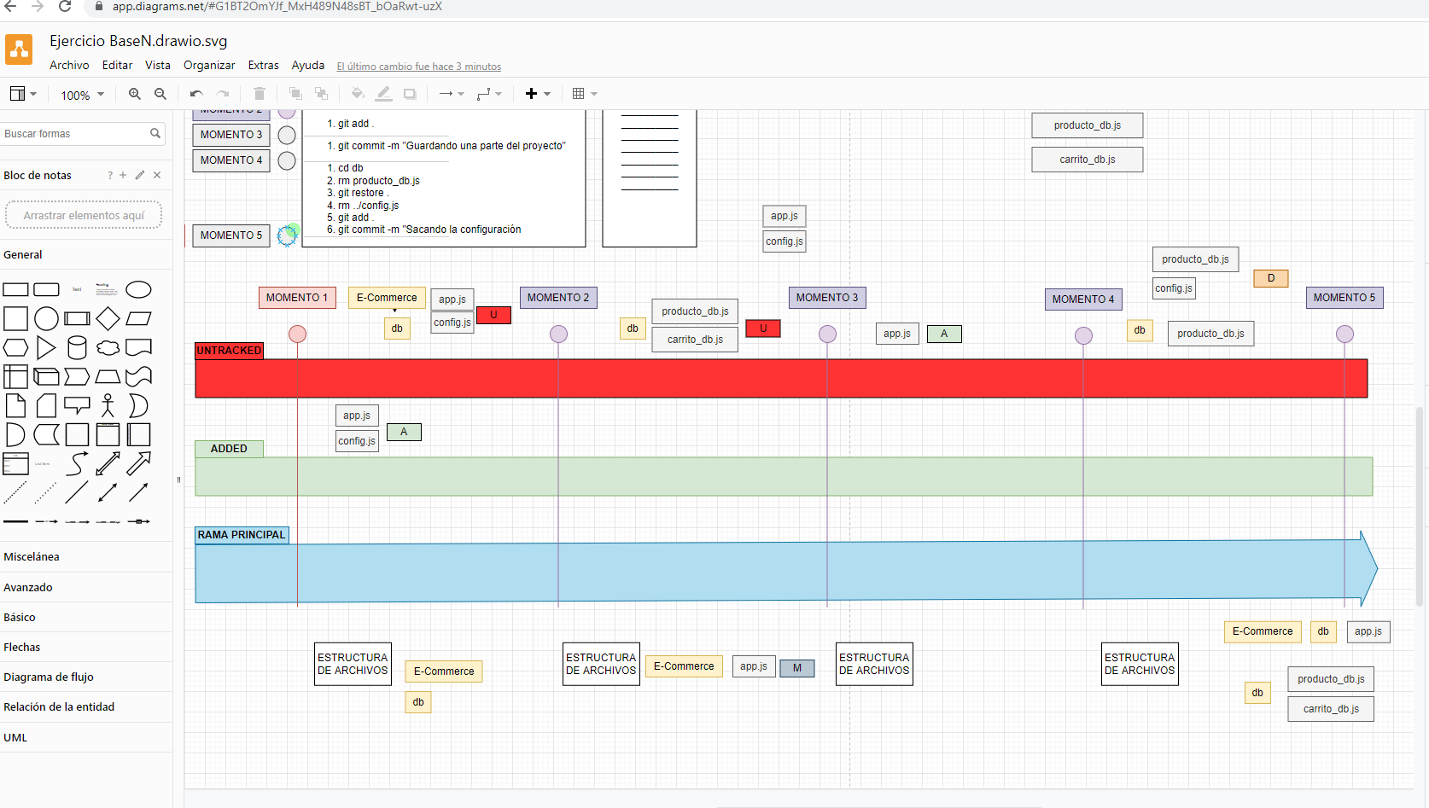

**Comandos Git:**

USER@DESKTOP-TTGDH4R MINGW64 ~/DH/ejercicioIntro

$ cd Ecommerce

USER@DESKTOP-TTGDH4R MINGW64 ~/DH/ejercicioIntro/Ecommerce

$ touch app.js

USER@DESKTOP-TTGDH4R MINGW64 ~/DH/ejercicioIntro/Ecommerce

$ touch config.js

USER@DESKTOP-TTGDH4R MINGW64 ~/DH/ejercicioIntro/Ecommerce

$ mkdir db

USER@DESKTOP-TTGDH4R MINGW64 ~/DH/ejercicioIntro/Ecommerce

$ git init

Initialized empty Git repository in C:/Users/USER/DH/ejercicioIntro/Ecommerce/.git/

USER@DESKTOP-TTGDH4R MINGW64 ~/DH/ejercicioIntro/Ecommerce (master)

$ git add .

USER@DESKTOP-TTGDH4R MINGW64 ~/DH/ejercicioIntro/Ecommerce (master)

$ git commit -m "Primer Commit"

[master (root-commit) 333e576] Primer Commit

2 files changed, 0 insertions(+), 0 deletions(-)

create mode 100644 app.js

create mode 100644 config.js

USER@DESKTOP-TTGDH4R MINGW64 ~/DH/ejercicioIntro/Ecommerce (master)

$ cd db

USER@DESKTOP-TTGDH4R MINGW64 ~/DH/ejercicioIntro/Ecommerce/db (master)

$ touch producto_db.js

USER@DESKTOP-TTGDH4R MINGW64 ~/DH/ejercicioIntro/Ecommerce/db (master)

$ touch carrito_db.js

USER@DESKTOP-TTGDH4R MINGW64 ~/DH/ejercicioIntro/Ecommerce/db (master)

$ cd ..

USER@DESKTOP-TTGDH4R MINGW64 ~/DH/ejercicioIntro/Ecommerce (master)

$ git commit -m "Guardando lo importante"

On branch master

Changes not staged for commit:

(use "git add <file>..." to update what will be committed)

(use "git restore <file>..." to discard changes in working directory)

modified: app.js

Untracked files:

(use "git add <file>..." to include in what will be committed)

db/

no changes added to commit (use "git add" and/or "git commit -a")

USER@DESKTOP-TTGDH4R MINGW64 ~/DH/ejercicioIntro/Ecommerce (master)

$ git add .

USER@DESKTOP-TTGDH4R MINGW64 ~/DH/ejercicioIntro/Ecommerce (master)

$ git commit -m "Guardando lo importante"

[master c4eb16d] Guardando lo importante

3 files changed, 1 insertion(+)

create mode 100644 db/carrito_db.js

create mode 100644 db/producto_db.js

USER@DESKTOP-TTGDH4R MINGW64 ~/DH/ejercicioIntro/Ecommerce (master)

$ git commit -m "Guardando una parte del proyecto"

On branch master

nothing to commit, working tree clean

USER@DESKTOP-TTGDH4R MINGW64 ~/DH/ejercicioIntro/Ecommerce (master)

$ git log

commit c4eb16d5194df2615401ec781cbfeaf71172ddc1 (HEAD -> master)

Author: angelidev <angelimaria75@gmail.com>

Date: Tue Aug 9 21:38:57 2022 -0500

Guardando lo importante

commit 333e576eadc413ec1d7145bfca522d85157a2179

Author: angelidev <angelimaria75@gmail.com>

Date: Tue Aug 9 21:29:16 2022 -0500

Primer Commit

USER@DESKTOP-TTGDH4R MINGW64 ~/DH/ejercicioIntro/Ecommerce (master)

$ cd db

USER@DESKTOP-TTGDH4R MINGW64 ~/DH/ejercicioIntro/Ecommerce/db (master)

$ rm producto_db.js

USER@DESKTOP-TTGDH4R MINGW64 ~/DH/ejercicioIntro/Ecommerce/db (master)

$ git restore .

USER@DESKTOP-TTGDH4R MINGW64 ~/DH/ejercicioIntro/Ecommerce/db (master)

$ rm ../config.js

USER@DESKTOP-TTGDH4R MINGW64 ~/DH/ejercicioIntro/Ecommerce/db (master)

$ git add .

USER@DESKTOP-TTGDH4R MINGW64 ~/DH/ejercicioIntro/Ecommerce/db (master)

$ git commit -m "Sacando la configuracion"

On branch master

Changes not staged for commit:

(use "git add/rm <file>..." to update what will be committed)

(use "git restore <file>..." to discard changes in working directory)

deleted: ../config.js

no changes added to commit (use "git add" and/or "git commit -a")

USER@DESKTOP-TTGDH4R MINGW64 ~/DH/ejercicioIntro/Ecommerce/db (master)

$